**AIQ Sales Analytics Unit Test**

1. **Testing Sales Data**
2. **Count check verified total record count and its matching in data lake against the file.**
   1. **File**

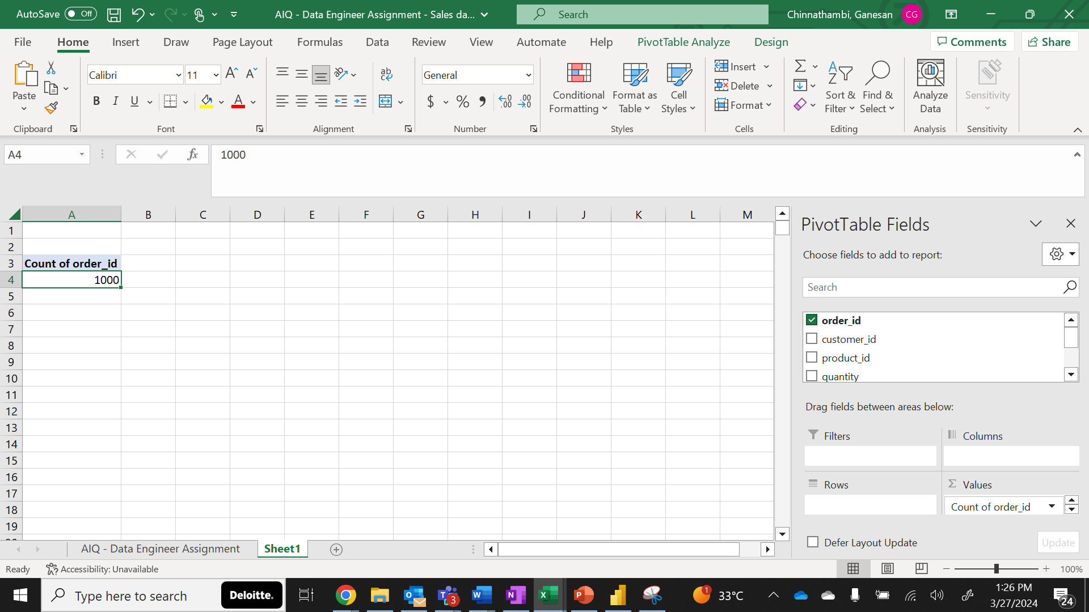

**1.2 Data Lake**

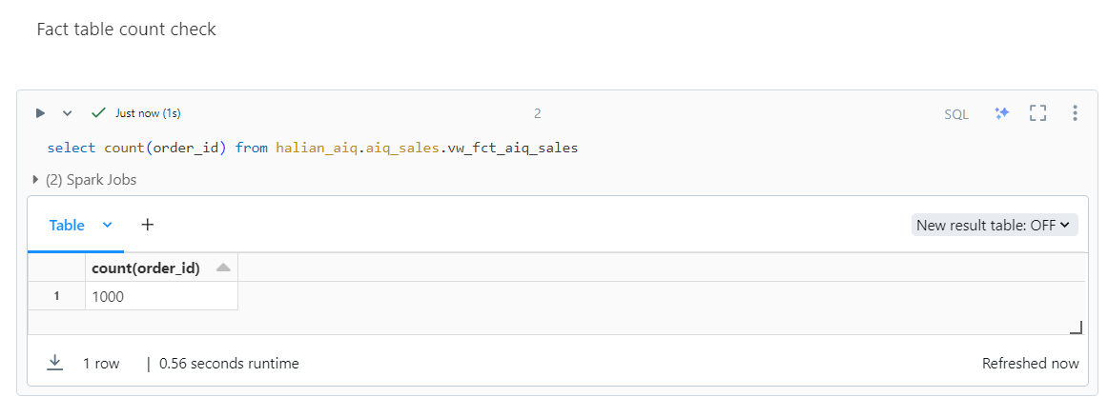

1. **Aggregate Customer wise order quantity and verified that are matching.**

**2.1. File**

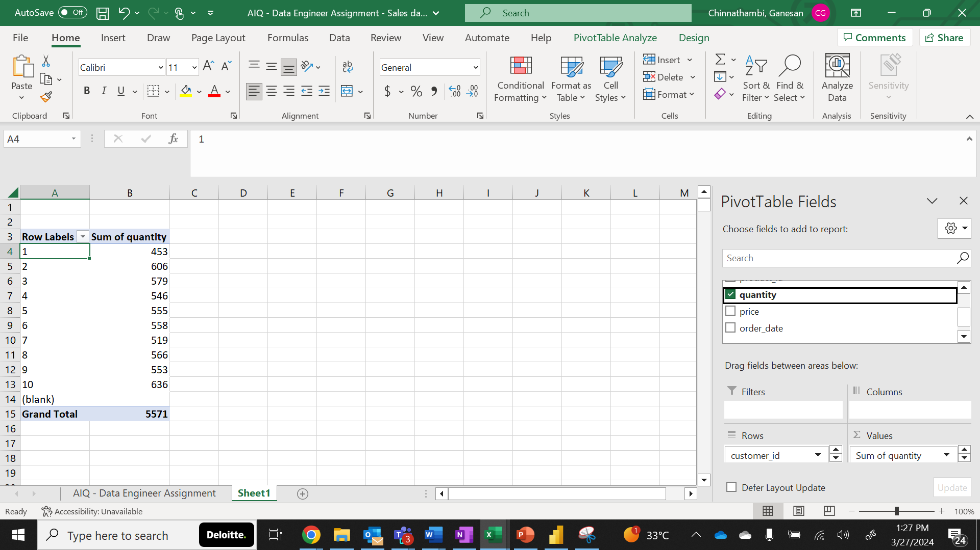

**2.2. Data Lake**

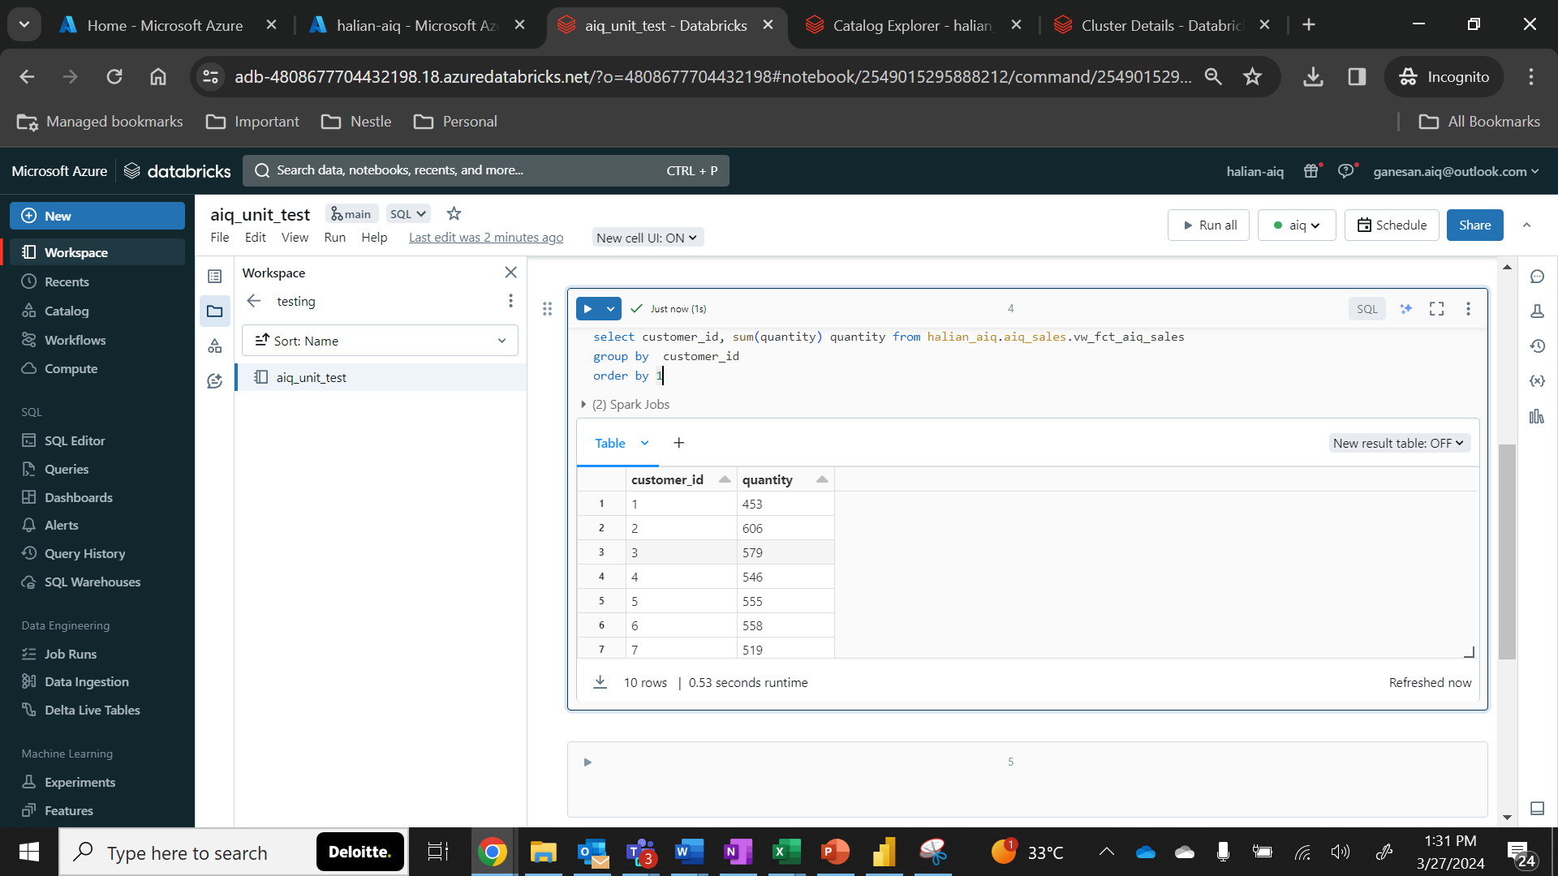

1. **Testing Customer Data for a customer**
2. **Random record check**
   1. **Source API**

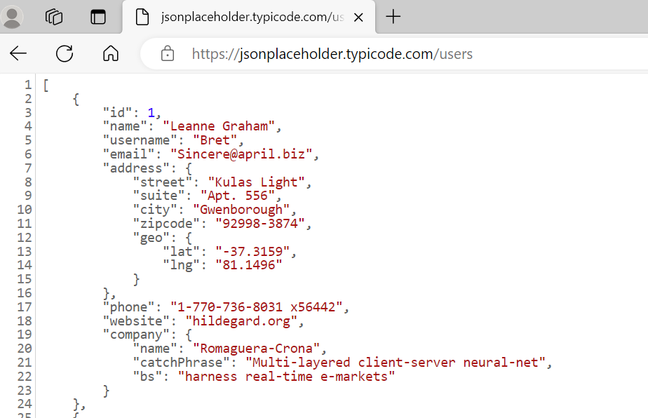

**Screenshot for address test**

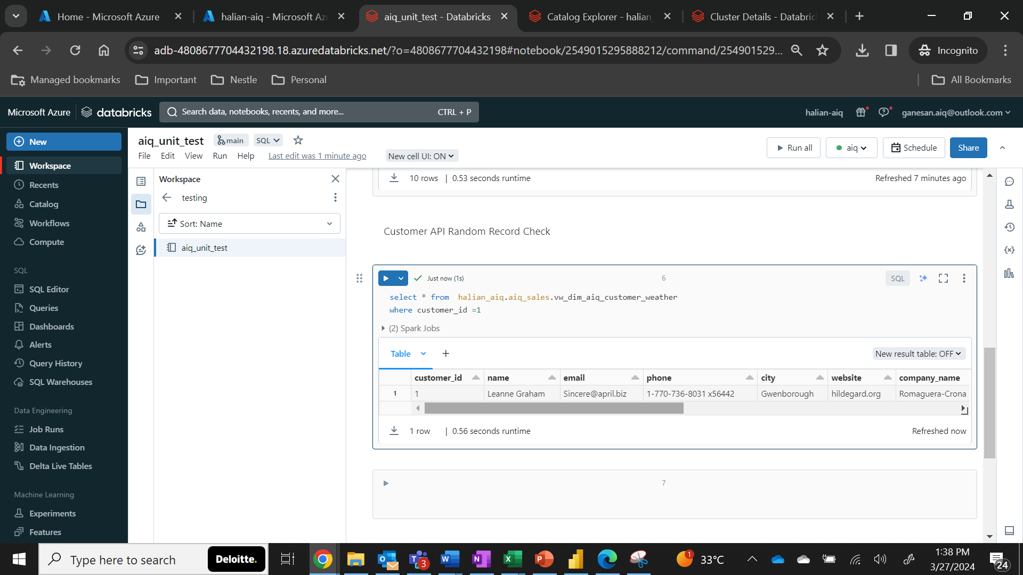

**Screenshot for Geo location test**

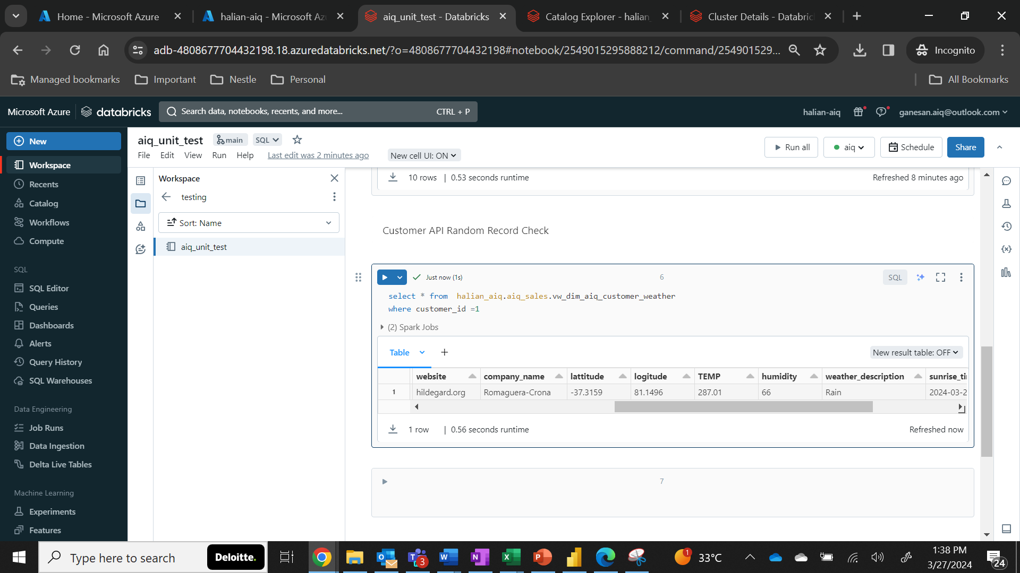

1. **Testing Customer Data for a Weather using customer’s latitude and longitude**

**For the above customer we have taken the lat and log and passed here:**

**API URL:** [**https://api.openweathermap.org/data/2.5/weather?lat=-37.3159&lon=81.1496&appid=a1132c1b00beefc7315e99f3c713f7f9**](https://api.openweathermap.org/data/2.5/weather?lat=-37.3159&lon=81.1496&appid=a1132c1b00beefc7315e99f3c713f7f9)

1. **Random record check**
   1. **Source API**

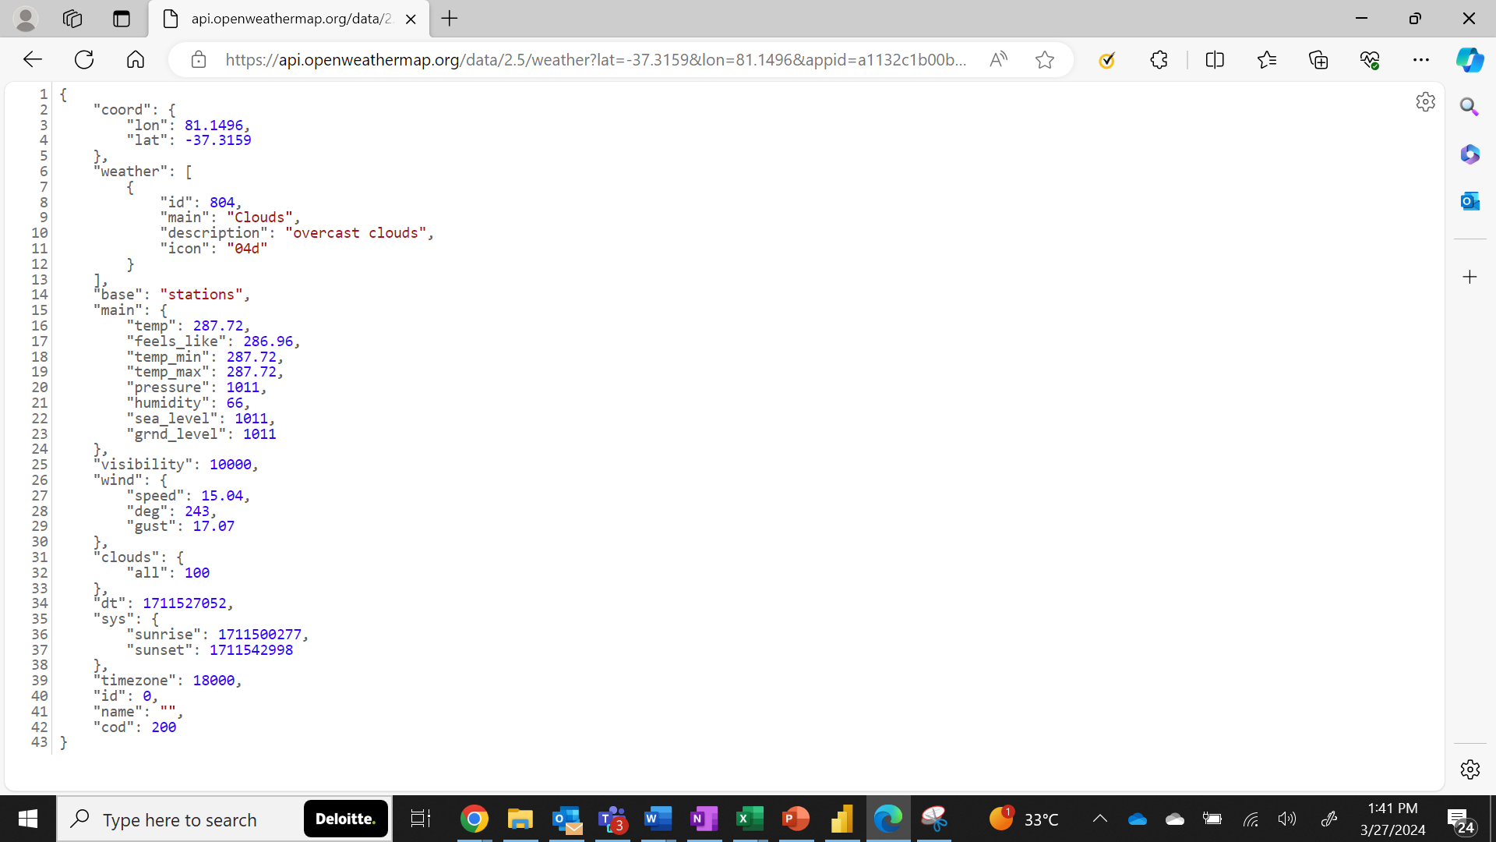

**1.2 Data Lake**

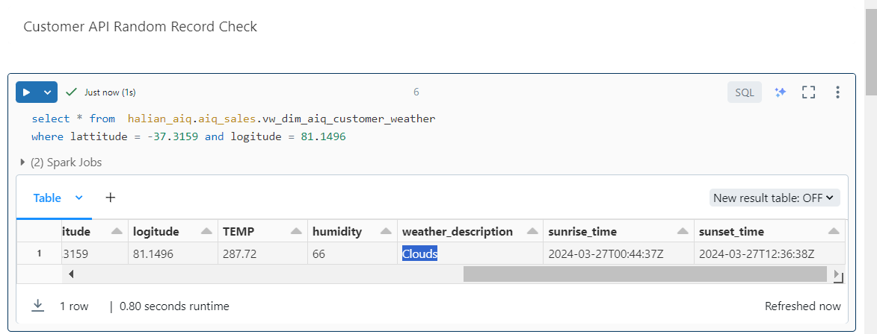

**Note: Sunrise and sun set are epoch time that has been transformed from epoch to clock time**